**MSDS 6370**

**HW 04**

Due: May 30, 2017

1. Sampling distribution of a finite population

|  |  |
| --- | --- |
| **Name** | **GPA** |
| A | 3.5 |
| B | 2.7 |
| C | 3.1 |
| D | 3.2 |
| E | 2.4 |

How many possible samples of size 3?

10

Specify the sampling distribution of sample means

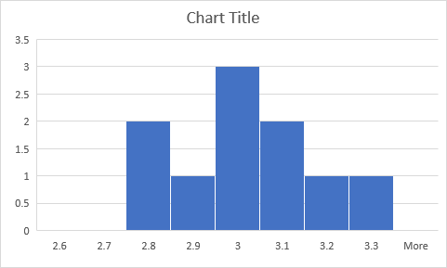

What is the mean of the sampling distribution of sample means?

2.98

What is the standard error of the sampling distribution of sample means?

0.1579